Assignment 3  
Name: Ryan Carey

ID: ruc230  
Date: 20 February 2019

**Question 1**

List Customer ID, Customer Name, Phone Number for Customers who live in Chicago, IL.

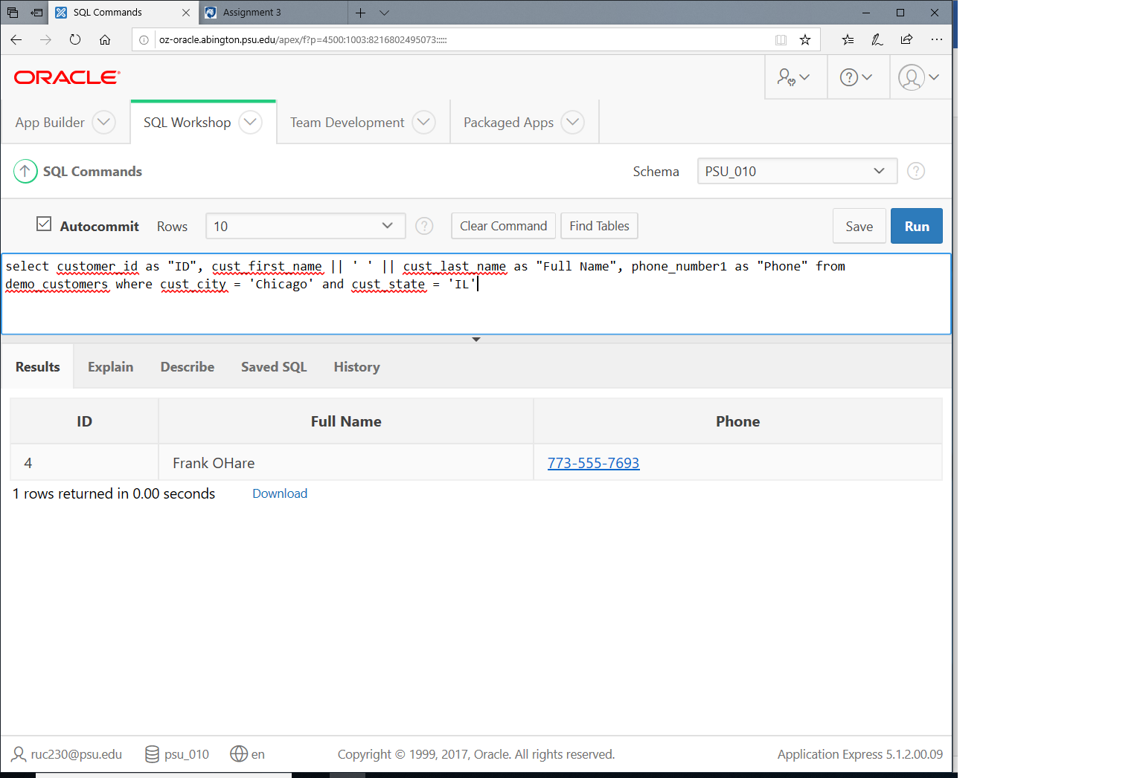

**Question 2**

List Product ID, Product Name, List Price for Products which are in women category.

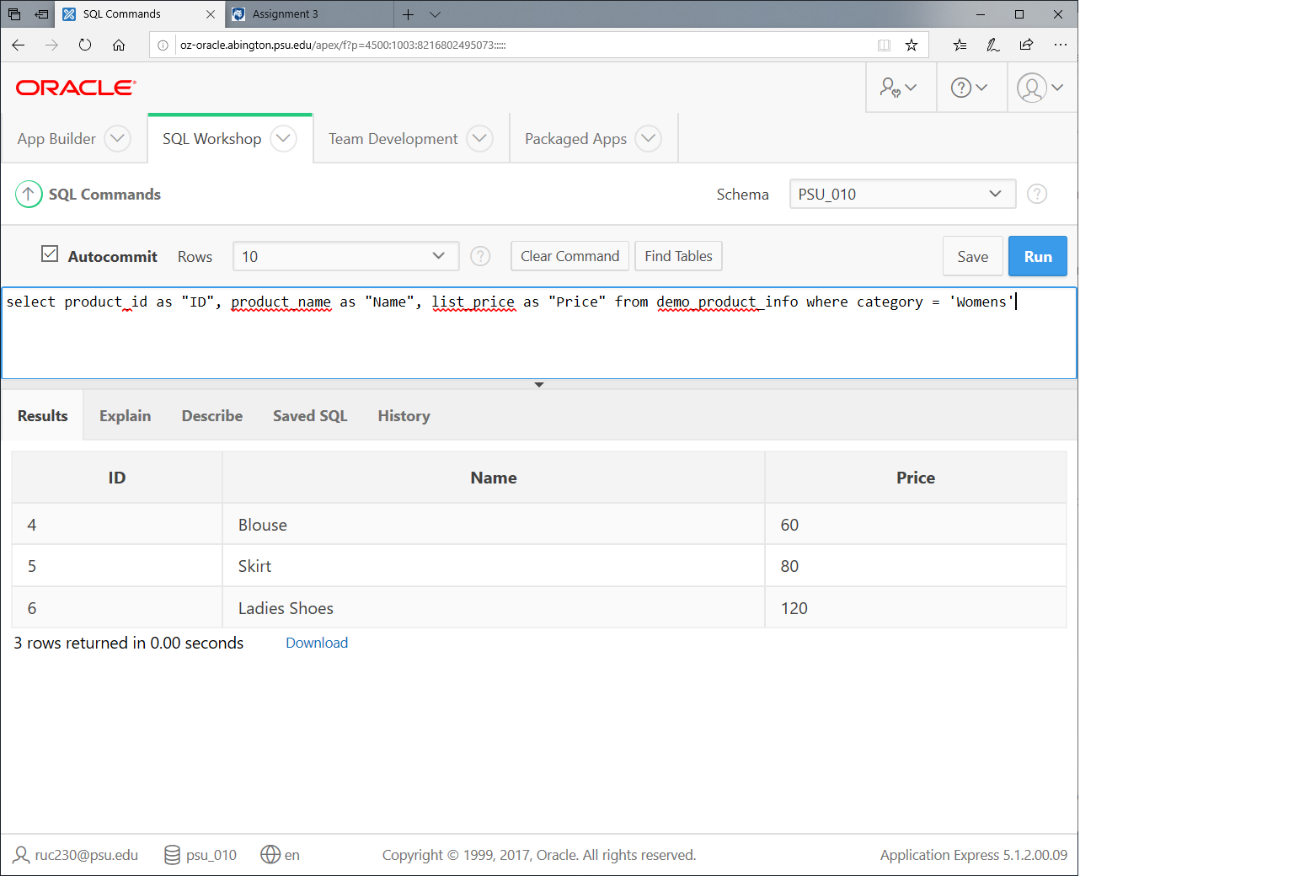

**Question 3**

List Product ID, Product Name, List Price for Products which are in women category and are top seller.

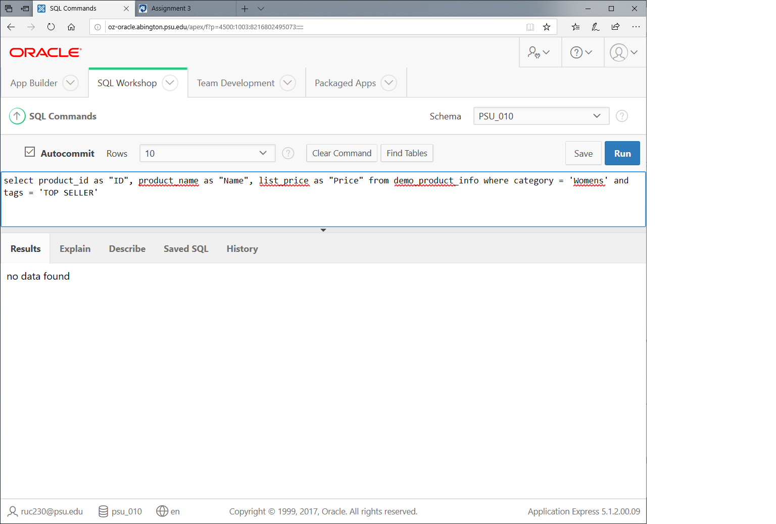

**Question 4**

List Order ID, Customer ID, Order Total, Order Date for Orders that are NOT LARGE ORDER.

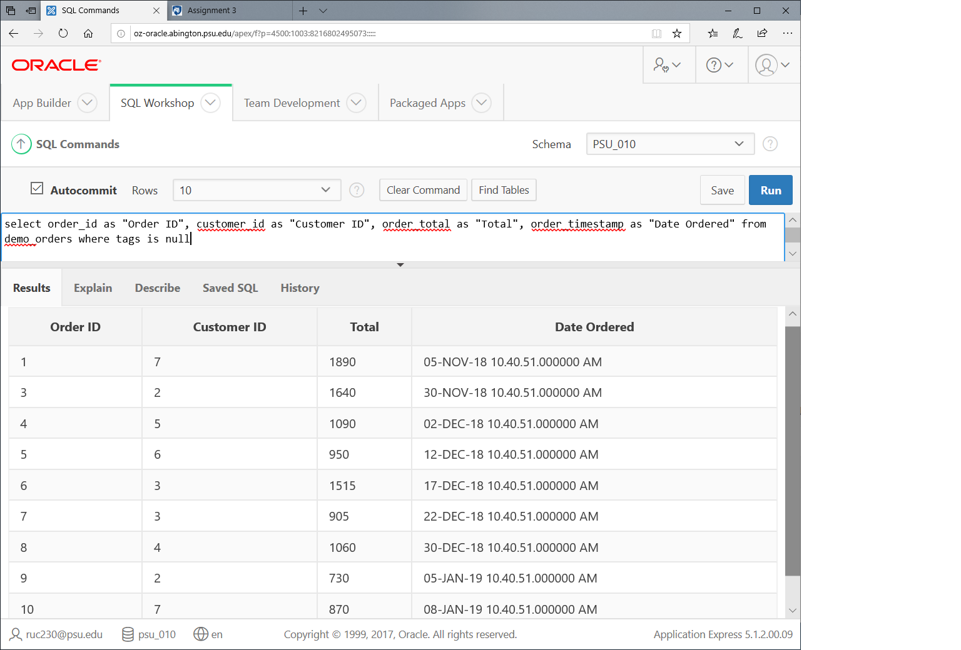

**Question 5**

List all state names in descending order (Full Names not two letter abbreviations) that includes letter 'M' anywhere in their name (case insensitive).

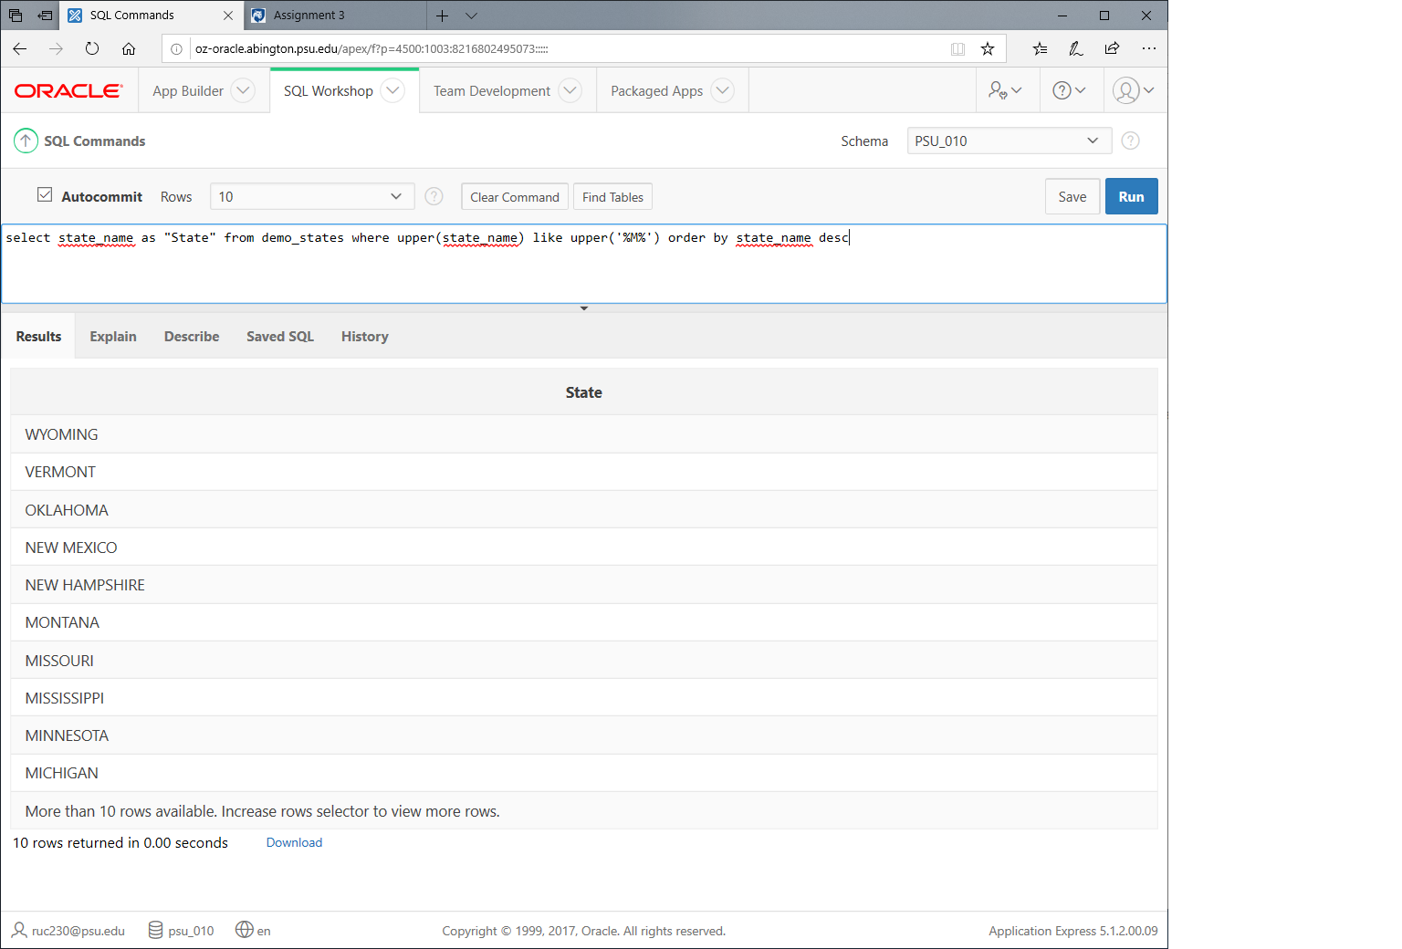

**Question 6**

List all Customers who live in PostalCode '30320'.

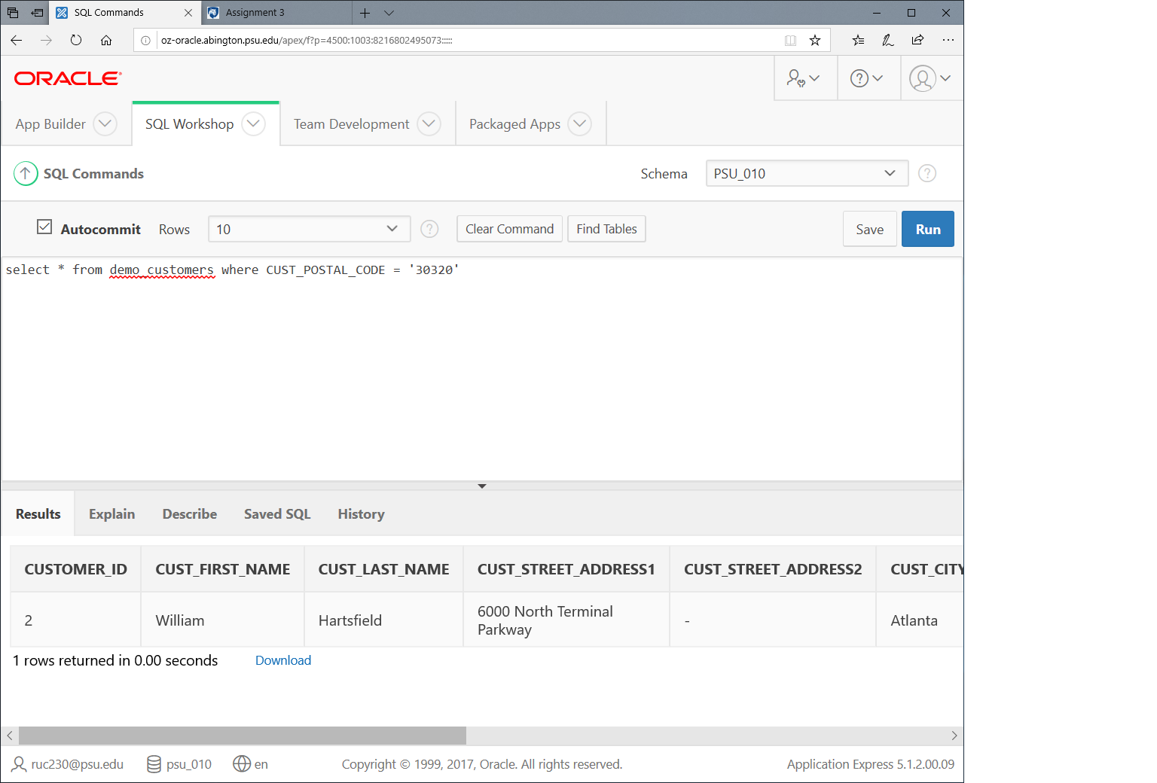

**Question 7**

List all Order Details for OrderID 2.

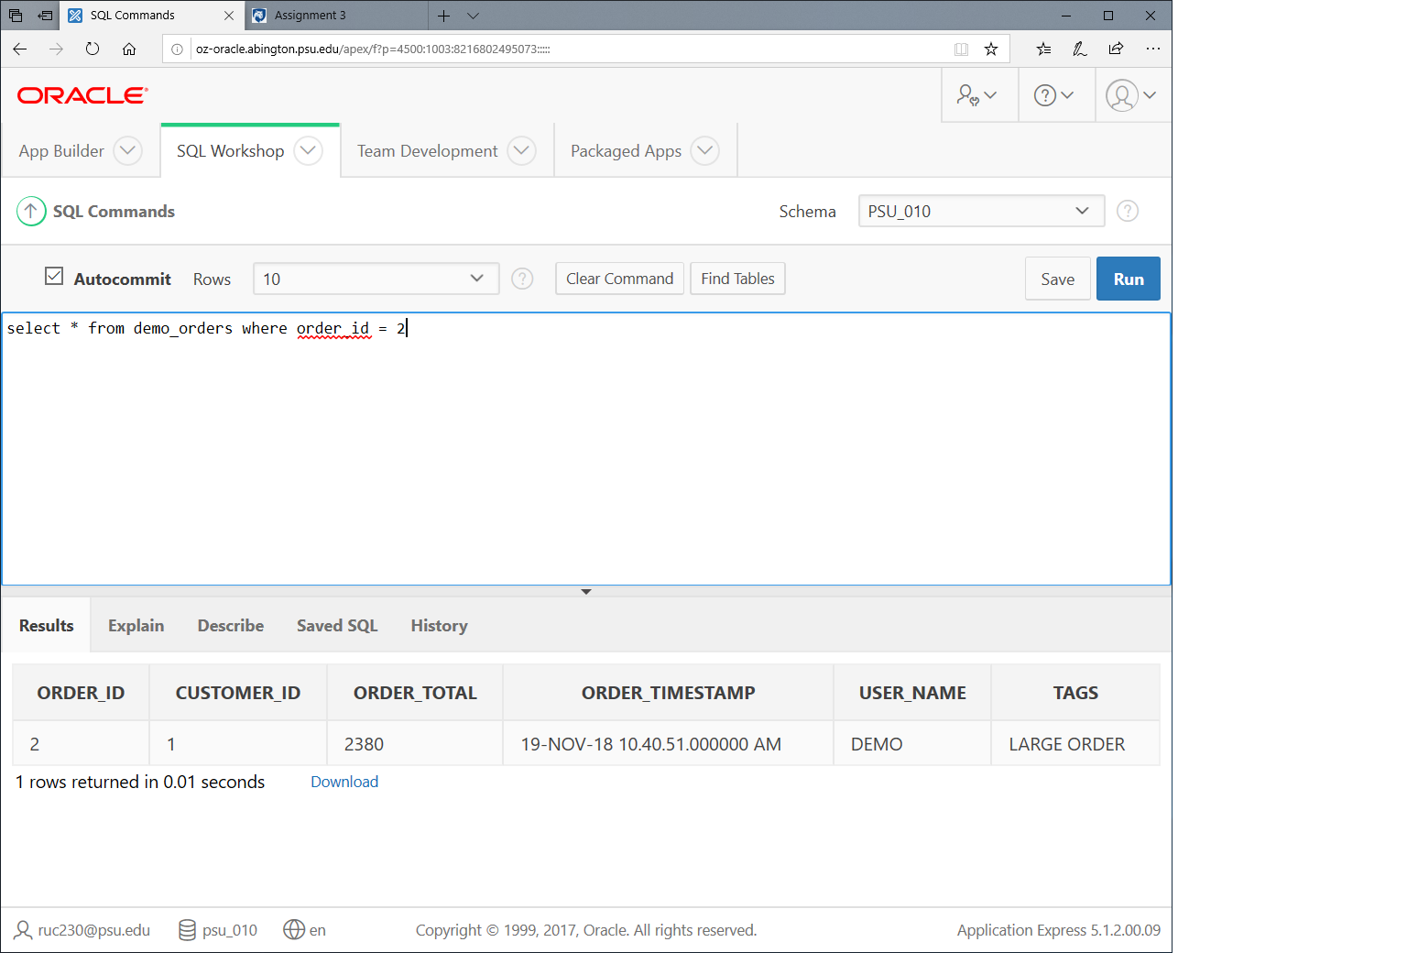

**Question 8**

List all leather products.

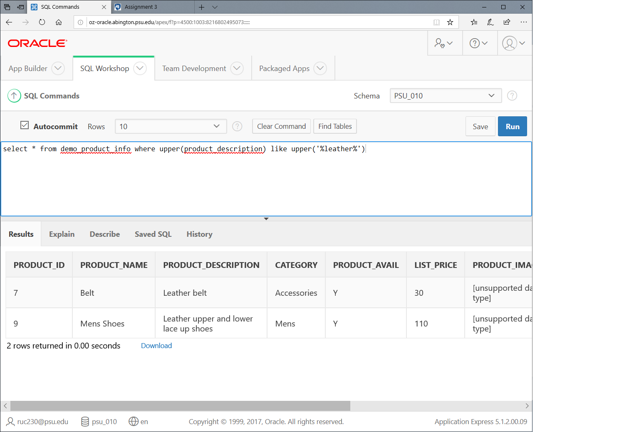

**Question 9**

List Customer ID, Customer Full Name, Customer Full Address who doesn't have a second street address.

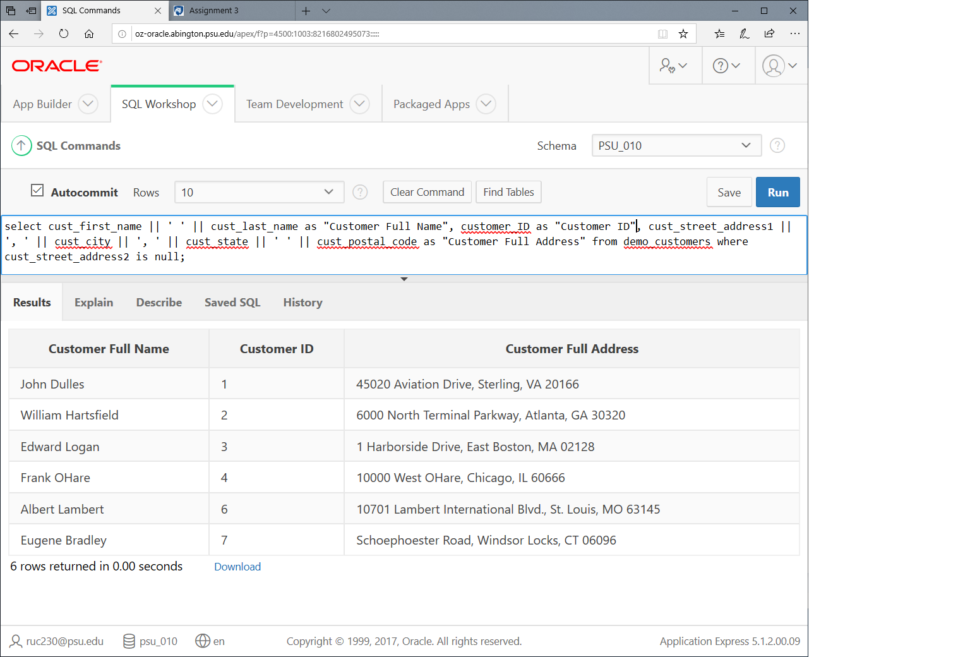

**Question 10**

List Customer ID, Customer Full Name, Phone Number 1 for Customers who don't live in VA.

